Silver Creations 2221 Jewel Street
Don and Kay Norris Longmont, Colorado 80501
303-517-1068 dnorris@frii.com

Price List
Stores wishing to have an exclusive to sell an item for their town, they must order a minimum of 12 of that item.

Pewter Castings
Pewter by Don Norris, cast by hand with lead free “American Fine Pewter” in Longmont, Colorado.

Lifesized Hummingbird Suggested Retail Price: $19.99
With ring for hanging.
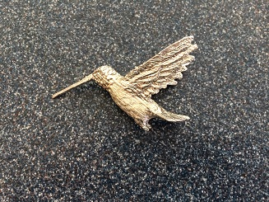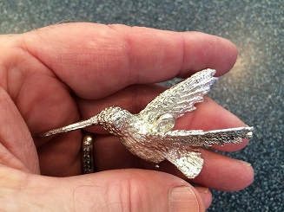
Wholesale Price 1 to 5: $14.99 each Wholesale Price 6 to 10: $7.49 Wholesale Price 11 or more: $6.99

Lifesized Columbine Suggested Retail Price: $19.99
With hole for beak of Hummingbird
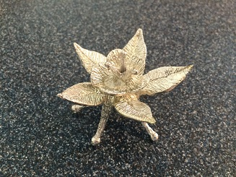
Wholesale Price 1 to 5: $14.99 each Wholesale Price 6 to 10: $9.99 Wholesale Price 11 or more: $7.99

Lifesized Hummingbird on Columbine Flower Sculpture Suggested Retail Price: $29.99
Hummingbird can be hung up as an ornament or displayed on the Columbine as a sculpture.
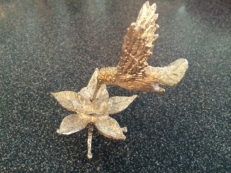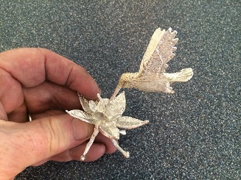
Wholesale Price 1 to 5: $29.99 each Wholesale Price 6 to 10: $14.99 Wholesale Price 11 or more: $12.49

Life Sized Butterfly Suggested Retail Price: $19.99
With ring for hanging.
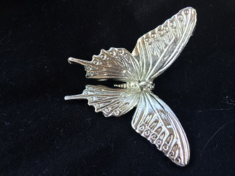
Wholesale Price 1 to 5: $14.99 each Wholesale Price 6 to 10: $7.49 Wholesale Price 11 or more: $6.99

Life Sized Rose Suggested Retail Price: $19.99
With hole for beak of Hummingbird
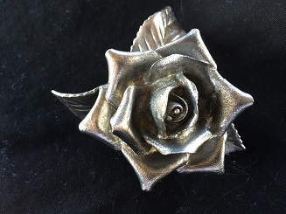
Wholesale Price 1 to 5: $14.99 each Wholesale Price 6 to 10: $9.99 Wholesale Price 11 or more: $7.99

Lifesized Butterfly and Rose Sculpture Suggested Retail Price: $29.99
Hummingbird can be hung up as an ornament or displayed on the Columbine as a sculpture.
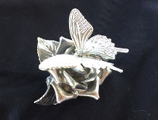
Wholesale Price 1 to 5: $29.99 each Wholesale Price 6 to 10: $14.99 Wholesale Price 11 or more: $12.49

Sterling Silver Castings
Price includes a 20 inch Sterling Silver Chain and crystal display box. A $2.00 discount will be given for no chain and box.
Each one is hand cast by Don Norris using the lost wax casting method. No animals were injured during casting!

Sterling Silver Best Bugling Elk Suggested Retail Price: $29.99
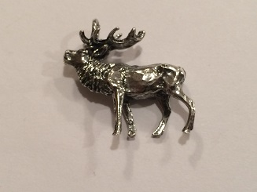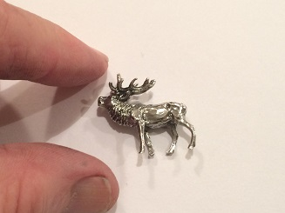
Wholesale Price 1 to 5: $19.99 each Wholesale Price 6 to 10: $14.99 Wholesale Price 11 or more: $12.99

Sterling Silver Best Standing Elk Suggested Retail Price: $29.99
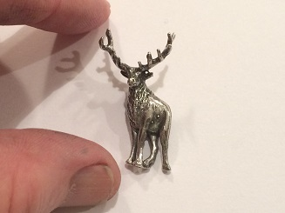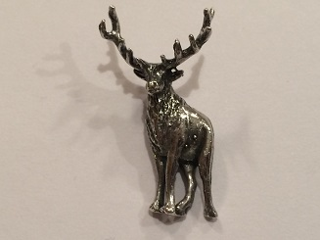
Wholesale Price 1 to 5: $19.99 each Wholesale Price 6 to 10: $14.99 Wholesale Price 11 or more: $12.99

Sterling Silver Best Running Horse Suggested Retail Price: $29.99
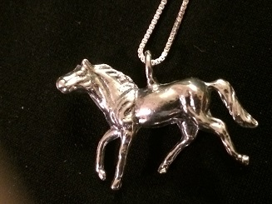
Wholesale Price 1 to 5: $19.99 each Wholesale Price 6 to 10: $14.99 Wholesale Price 11 or more: $12.99

Sterling Silver Fancy Horse Suggested Retail Price: $29.99
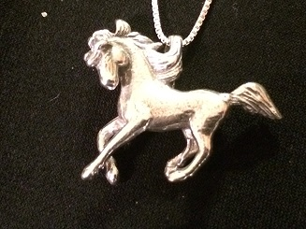
Wholesale Price 1 to 5: $19.99 each Wholesale Price 6 to 10: $14.99 Wholesale Price 11 or more: $12.99

Sterling Silver Frog on Leaf Set Suggested Retail Price: $39.99
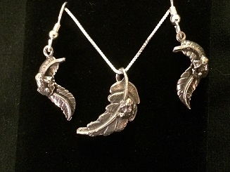
Wholesale Price 1 to 5: $29.99 each Wholesale Price 6 to 10: $19.99 Wholesale Price 11 or more: $15.99
Sterling SilverFrog on Leaf Pendant Only
Wholesale Price 1 to 5: $14.99 each Wholesale Price 6 to 10: $9.99 Wholesale Price 11 or more: $8.99
Sterling Silver Frog on Leaf Earrings Only
Wholesale Price 1 to 5: $16.99 each Wholesale Price 6 to 10: $12.99 Wholesale Price 11 or more: $9.99

Pine Cones Cast in Solid Sterling Silver
Each Pine Cone is hand cast by burning up the pine cones and casting them using the lost wax casting method.
(Note: no two will be the same, each one is cast from a sperate real pine cone.)

Single Sterling Silver Pine Cones Suggested Retail Price: $29.99
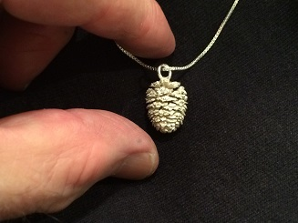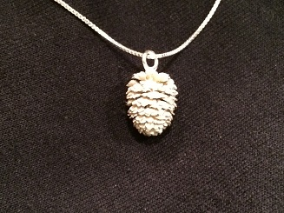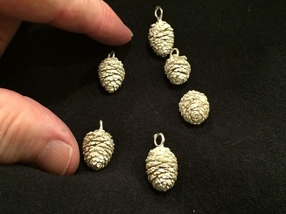
Wholesale Price 1 to 5: $19.99 Wholesale Price 6 to 10: $14.99 Wholesale Price 11 or more: $12.49

Double Sterling Silver Pine Cones Suggested Retail Price: $39.99
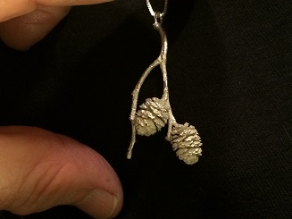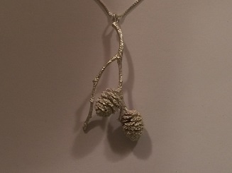
Wholesale Price 1 to 5: $29.99 each Wholesale Price 6 to 10: $19.99 Wholesale Price 11 or more: $14.99

Triple Sterling Silver Pine Cones Suggested Retail Price: $49.99
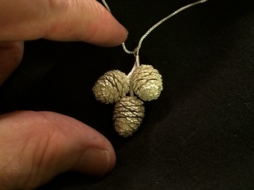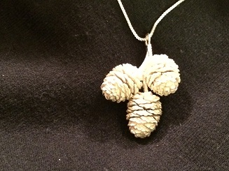
Wholesale Price 1 to 5: $34.99 Wholesale Price 6 to 10: $24.99 Wholesale Price 11 or more: $19.99

Sterling Silver Pine Cone Earrings Suggested Retail Price: $49.99
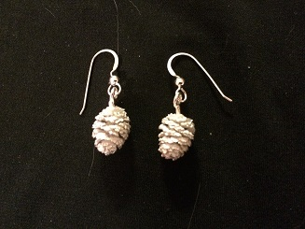
Wholesale Price 1 to 5: $34.99 Wholesale Price 6 to 10: $29.99 Wholesale Price 11 or more: $24.99

Solid .999 Fine Silver Pine Needle Castings
Each is hand made by melting and pouring 1/3 ounce of pure .999 Fine Silver into a bundle of pine needles.
No two will look the same, weigh the same, or be the same size.

.999 Fine Silver Pine Needle Castings Suggested Retail Price: $39.99

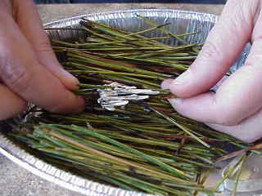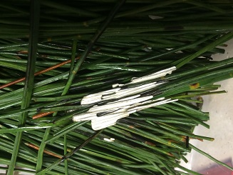

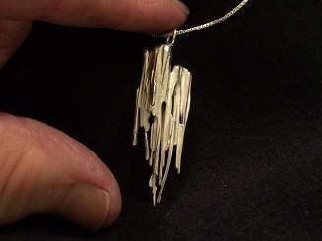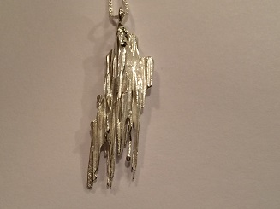

Wholesale Price 1 to 5: $29.99 Wholesale Price 6 to 10: $24.99 Wholesale Price 11 or more: $19.99

Sterling Silver “Doodles” Pendants
Price includes a 20 inch Sterling Silver Chain and crystal display box. A $2.00 discount will be given for no chain and box.
Each one is hand soldered and we like to call them doodles, Sterling Silver Doodles.
Each one is original and is constructed using 18 gauge Sterling Silver round wire. The wires are bent and then soldered together individually. Then a faceted synthetic “Birthstone” is added to each. Many are made using a new synthetic faceted crystal, Cobalt Blue Ice exclusively faceted for Don Norris.

Sterling Silver Doodle Pendant Suggested Retail Price: $29.99

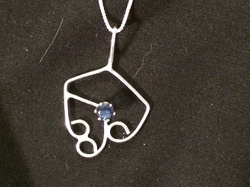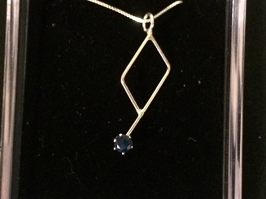

Wholesale Price 1 to 5: $24.99 each Wholesale Price 6 to 10: $19.99 Wholesale Price 11 or more: $14.99

Sterling Silver Hummingbirds

Sterling Silver Small Hummingbird Earrings Suggested Retail Price: $11.99
Price includes Sterling Silver Ear Wires and crystal display box. A $2.00 discount will be given for no earwires and box.

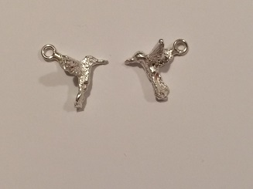

Wholesale Price 1 to 5: $8.99 each Wholesale Price 6 to 10: $5.99 Wholesale Price 11 or more: $4.99

Large Sterling Silver Floral Pendant with Hummingbird Suggested Retail Price: $29.99

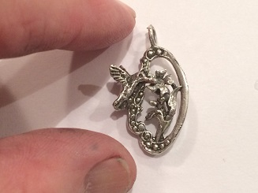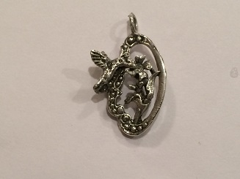

Wholesale Price 1 to 5: $15.99 each Wholesale Price 6 to 10: $10.99 Wholesale Price 11 or more: $9.99

Large Sterling Silver Floral Pendant with Hummingbird and Earrrings Suggested Retail Price: $24.99

Wholesale Price 1 to 5: $24.99 each Wholesale Price 6 to 10: $15.99 Wholesale Price 11 or more: $13.49

Small Sterling Silver Floral with Hummingbird Pendant Suggested Retail Price: $19.99

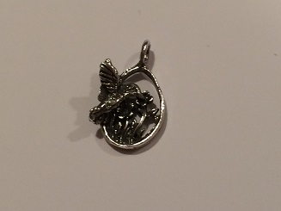

Wholesale Price 1 to 5: $14.99 each Wholesale Price 6 to 10: $9.99 Wholesale Price 11 or more: $8.99

Small Sterling Silver Floral with Hummingbird Pendant and Earrrings Suggested Retail Price: $24.99

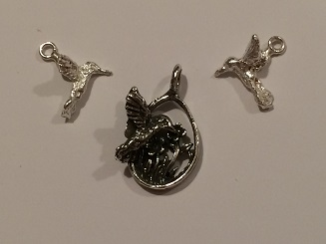

Wholesale Price 1 to 5: $24.99 each Wholesale Price 6 to 10: $14.99 Wholesale Price 11 or more: $12.49
Sterling Silver Skeletons (Bones)
Sterling Silver Bones Suggested Retail Price: $29.99
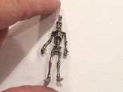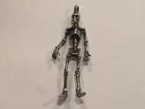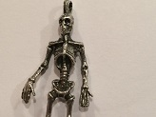
Wholesale Price 1 to 5: $16.99 each Wholesale Price 6 to 10: $12.99 Wholesale Price 11 or more: $9.99

Sterling Silver Cowboy Bones Suggested Retail Price: $29.99
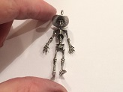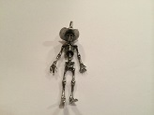
Wholesale Price 1 to 5: $18.99 each Wholesale Price 6 to 10: $12.99 Wholesale Price 11 or more: $9.99

Sterling Silver Half Soldier Bones Earrings Suggested Retail Price: $39.99
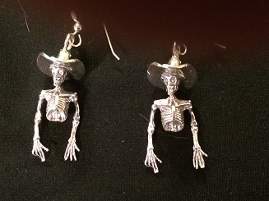
Wholesale Price 1 to 5: $29.99 each Wholesale Price 6 to 10: $19.99 Wholesale Price 11 or more: $15.99

Sterling Silver Bones Cowboy Earrings Suggested Retail Price: $29.99
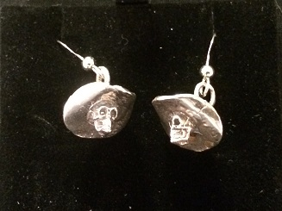
Wholesale Price 1 to 5: $16.99 each Wholesale Price 6 to 10: $12.99 Wholesale Price 11 or more: $9.99

Sterling Silver Bones Skier Suggested Retail Price: $39.99
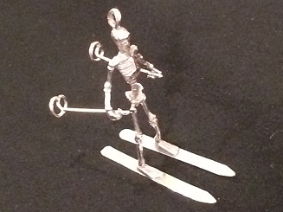
Wholesale Price 1 to 5: $29.99 each Wholesale Price 6 to 10: $19.99 Wholesale Price 11 or more: $15.99

Sterling Silver Cowboy Bones Skier Suggested Retail Price: $39.99
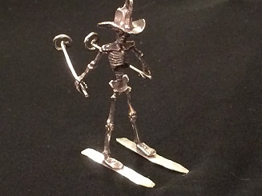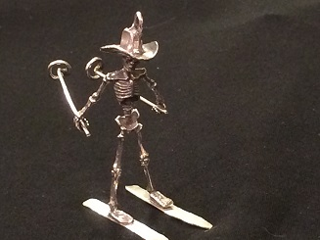
Wholesale Price 1 to 5: $29.99 each Wholesale Price 6 to 10: $19.99 Wholesale Price 11 or more: $15.99
Sterling Silver Wire Sculpture Earrings
Each one is hand crafted by Don Norris using only a pair of pliers.
Some of the sculpture have earwires that are part of the sculpture or are hung on Sterling Silver Earwires.
Price includes Sterling Silver Ear Wires and crystal display box. A $1.00 discount will be given for no earwires and box.
Note: no two pairs will be the exact same size.

Sterling Silver Hummingbird Earrings Suggested Retail Price: $19.99
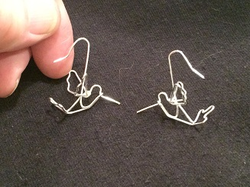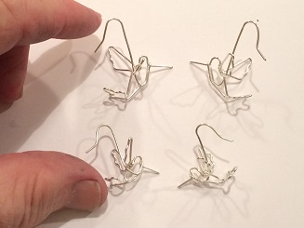
Wholesale Price 1 to 5: $14.99 each Wholesale Price 6 to 10: $9.99 Wholesale Price 11 or more: $8.99

Sterling Silver Angel Earrings (Note: no two pairs will be the exact same size) Suggested Retail Price: $19.99
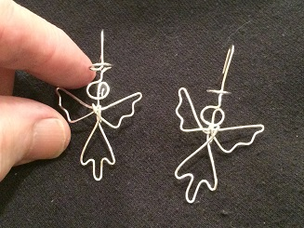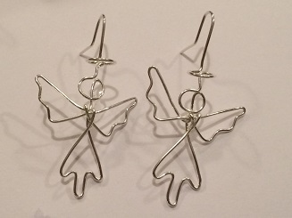
Wholesale Price 1 to 5: $14.99 each Wholesale Price 6 to 10: $9.99 Wholesale Price 11 or more: $8.99

Black Widow Spiders Cast in Solid Sterling Silver
Each Black Widow is hand cast by burning up a Black Widow, molding it, and casting them using the lost wax casting method.

Sterling Silver Black Widow Spider on Web Suggested Retail Price: $39.99
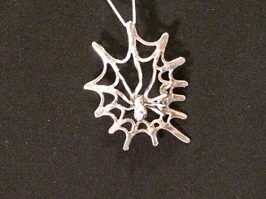
Wholesale Price 1 to 5: $29.99 each Wholesale Price 6 to 10: $19.99 Wholesale Price 11 or more: $15.99

Sterling Silver Black Widow Pendant Suggested Retail Price: $29.99
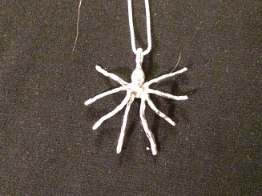
Wholesale Price 1 to 5: $19.99 each Wholesale Price 6 to 10: $14.99 Wholesale Price 11 or more: $12.99

Sterling Silver Black Widow Spider Earrings Suggested Retail Price: $39.99
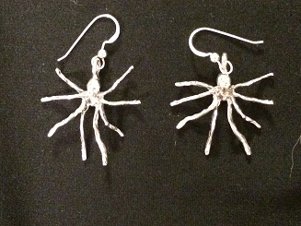
Wholesale Price 1 to 5: $29.99 each Wholesale Price 6 to 10: $19.99 Wholesale Price 11 or more: $15.99

